SAMBUCA ON THE NCI/AGDC

SELECTED COMPONENT DESCRIPTIONS

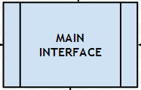

1. INTERFACE FOR THE USER TO CHOOSE PARAMETERISATION AND OPTIONS FOR A JOB

Data Selection

* Selection via Geographic location / Tile / Sensor
* Option to select data based on QA assessment (component 2)
* Associated sensor filters and noise based on data selection

SIOP Selection Options

* SIOP and ranges based on tile based Optical Water Type (see component 3)
* SIOP and ranges based on expert user knowledge
* Ranges based on Pre-optimisation routine (see component 5)

Substrate Library Selection Options

* Simple selection of user defined number of representative substrates (see component 4)
* Site specific substrate selection based on expert knowledge

Generic Noise (NEDR) Selection Options

* Simple selection of user defined number of noise (NEDR) spectra (see component 4)
* Specific NEDR selection based on expert knowledge

Parallel Processing Options

* The user can specific the number of parallel processing nodes to be used in the job, and the nature of the division of data (see component 8)

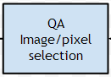

1. Quality Assessment of Tile and Pixel Data

Provides the option of selecting the best available data in the archive at a given tile and/or pixel location. This module can utilise the existing pixel quality layers in the AGDC and a geometry based glint risk assessment to evaluate each image tile in terms of quality for aquatic applications.

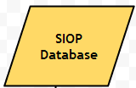

1. Specific Inherent Optical Properties (SIOP) Database

A comprehensive database of SIOP sets (values and spectra) and associated water constituent ranges for various regions in Australia. The user can access and use the database in a number of ways:

* At the simplest level, an SIOP set and ranges will be stored and attributed automatically to each individual tile in the AGDC. This will be based on a first pass assessment by CSIRO as part of the database construction. This requires the archival SIOP/IOP database to be categorise, based on an optical water type classification scheme (developed by Moore et al, 2009).
* The user can select any SIOP and range based on site specific or expert knowledge.
* The user can select an SIOP range, and ranges derived from the pre-optimisation module (see component 5)

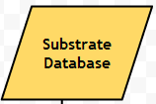

1. Substrate Spectral Library Database

* A comprehensive archival database of benthic substrate spectra, separated using the normalized Spectral Separability Metric, (nSSM in Botha, et al. 2013) into four broad classesfor Landsat 8 bands. This will be based on analysis by CSIRO as part of the database construction. The substrates were grouped using the NISB classification scheme (Mount, et al, 2007): Seagrasses
* Corals
* Consolidated and Unconsolidated Sediments
* Macro-algae

At the simplest level, a representative substrate spectra will be assigned to each class in the database. The user can then choose to use the representative substrate for any number of classes, or to pick a specific substrate library combination based on knowledge and requirements.

This enables flexible implementation for users with different end uses and requirements. This may range from a simple dark/light substrate implementation, to a full library for benthic habitat mapping purposes.

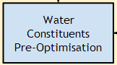

1. Pre-optimisation of Water Constituent ranges

This module provides the option to uses the Sambuca forward model to estimate the optimisation ranges that might be required in inversion for the water constituent concentrations (if depth data is available)

This is similar to the “Get Z” function currently in Sambuca, which uses known depth data (LADS etc) to constrain a solution and isolate expected ranges for the components of the water column. This can be helpful for regions where there is little knowledge of the ranges and variability of these components. The option to constrain the Landsat data with the 10m depth contour will enable testing of the input ranges and OWTs.



1. Noise Equivalent Difference in Reflectance Spectral Library Database

This module provides the option to uses the predefined NEDR spectra for the Landsat 8 imagery. The NEDR spectra will be defined based sun angle, season and latitude. This will be based on analysis by CSIRO as part of the database construction.

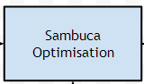

1. Sambuca Module

This is the core of the inversion algorithm based on an optimisation approach to fit a modelled reflectance spectra to the observed pixel spectra.

A physics based radiative transfer model is used to incorporate the SIOP, substrate, noise and image data and to infer the best fitting solution for the parameters of interest in the inversion optimisation. Other outputs regarding the quality of the solution are also output as part of the inversion.

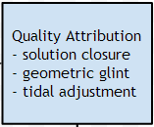

1. Solution Quality and Attribution module

This module attributes and adjusts the outputs for each pixel from the Sambuca optimisation. Included here are processes that may not be part of the Sambuca process itself, but may be required for the solution outputs products eg. Pixel based glint risk, tidal adjust of derived depth.

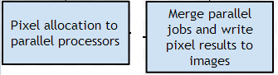

1. Parallel Processing Modules

These modules divide the inversion job based on the request from the user in the main interface. For example, a user can choose to send the job to 10 processing nodes. The image tile will then be split into ten sub-tiles, processed on a per-pixel basis, and then the results merged at the completion of the job.

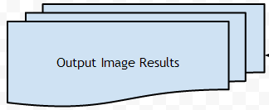

1. Output Image Results

TBD

References:

Botha, E.J., Brando, V.E., Anstee, J.M., Dekker, A.G. and Sagar, S. (2013) Increased spectral resolution enhances coral detection under varying water conditions. *Remote Sensing of Environment*. 2013; 131:247-261.

Moore, T. S., J. W. Campbell & M. D. Dowell (2009) A class-based approach to characterizing and mapping the uncertainty of the MODIS ocean chlorophyll product. *Remote Sensing of Environment,* 113**,** 2424-2430.

Mount R, Bricher P & Newton J. 2007. NISB Habitat Classification Scheme. Report to the National Land and Water Resources Audit. <http://lwa.gov.au/products/pn21267>